Practical math ideas for nursery
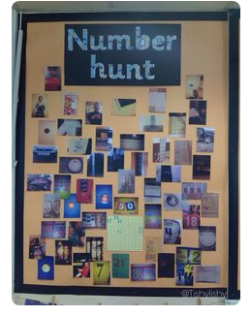 | Going on a number hunt. When you are out look out for different numbers. They could be on doors, shops, number plates on cars etc. Numbers are everywhere. You could even take pictures and look at them later. | 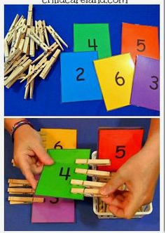 | Pegging numbers. Get children to say the number and then peg on that amount of pegs. Even if they don’t recognise the number yet you can still practice counting.
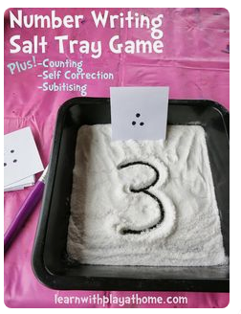 | If you have a tray or plate, put some sand or spare salt on it and encourage your child to write the numbers. You may need to write it first on paper to show them. | 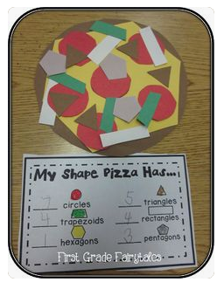 | Making a shape pizza. Have shapes ready for children to create their own pizza. It is a great way to get children talking about shapes and describing what they see.
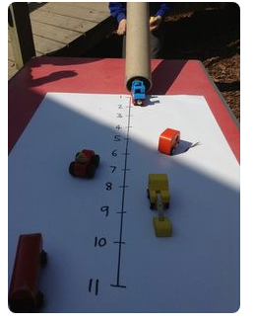 | You could measure how far your car moved. This will be a fun way to recognise and talk about numbers.  You can even use language like far/near/close etc. to talk about distance. | 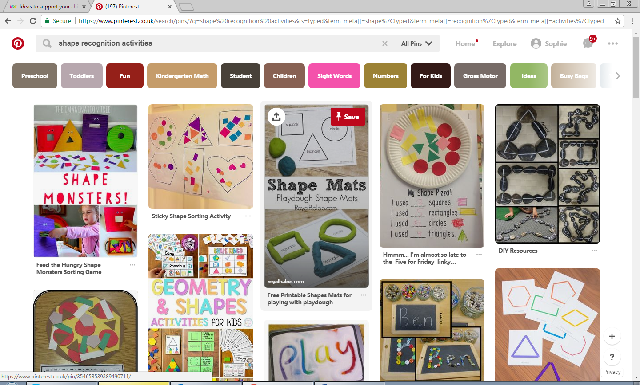 | Monster shapes. To make it a bit more exciting you can cut shapes out of card and give them a ‘mouth’ for children to feed with smaller shapes. Old cereal boxes are a great source of card.
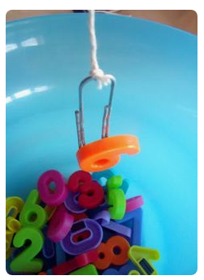 | Fishing for numbers. Take the magnetic numbers off the fridge and out into a bowl. If you have a paper clip and string you can make a fishing rod. Children can say the number they catch! |  | Matching shapes. You can draw on a large piece of paper and cut out shapes for children to match. If you have plastic shape you can use those again and again!
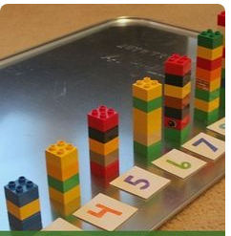 | Building with numbers. Get your child to count out the bricks they use to make different towers. Match it up with the numbers. | 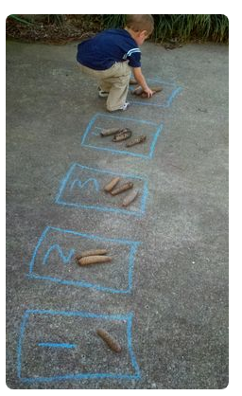 | Numbers outside. If you have some chalk you can do this at home or in the park. Draw the number in a box and go and find objects to place inside e.g. 5 leaves, 4 sticks, 3 stones etc.

