Fine motor and writing ideas
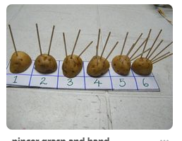 | Stick in the potato. You could use any hard veg or fruit. Push the correct number of sticks into the vegetable. It’s great for hand strength and math too. | 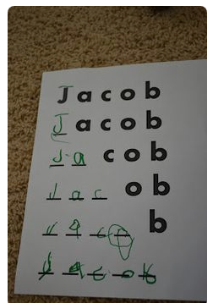 | Building up your name. Start by reading your name at the top. As you go down each line you can add another letter. Adults you can write the letters rather than printing a sheet like shown.
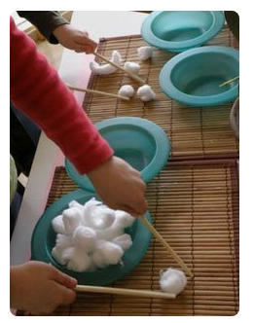 | Moving cotton wool. Use chopsticks to pick up and move cotton wool balls from bowl to bowl. Adults will have lots of fun too! | 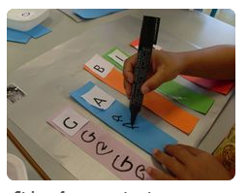 | Colourful name writing. To make it a bit more interesting you can practice the different letters on colour strips and line them up next to each other.
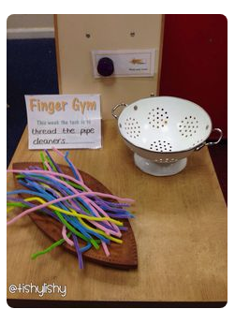 | Thread the straws or pipe cleaners through the holes in the colander.  You can count how long it takes you to pull them all out at the end. | 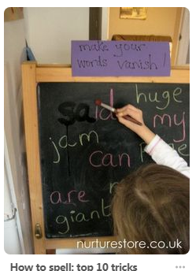 | Disappearing words! Adults can write letters on the chalk board and children can paint over with water to make then disappear. Magical fun for the children.
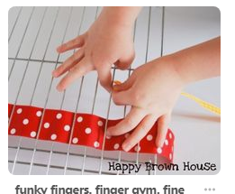 | Children can thread bits of ribbon or strips of old material through the cooling rack or grill tray. Can you make different patterns? | 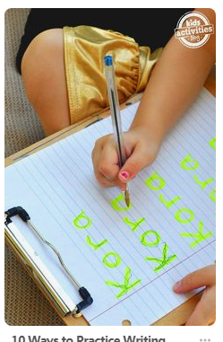 | Tracing practice. The adult can write the child’s name with a high lighter and the child can use their favourite pen to practice writing over it.
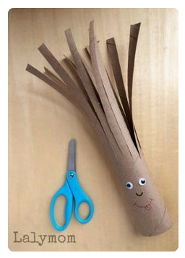 | Snipping fun. Can you give your old kitchen or toilet roll a lovely hair cut?  You can even draw a funny face on it.  Please use children’s scissors and always with adult supervision. | 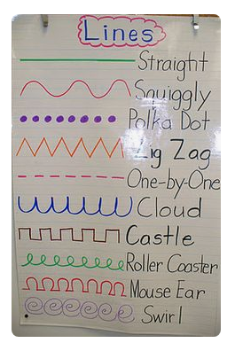 | Pre-writing lines.  These lines are great practice for children’s handwriting. You can do it first with a highlighter or light colour felt tip pen and children can trace on top.

