Year 5: A sense of Place- Summer 1
Key Vocabulary |  |  |  | Key knowledge |  | Key concepts
landscapes | A painting of nature and the land such as the ocean, mountains, trees, and sky. |  |  | TO know that a view finder can help us to find interesting views and features  To understand that artists use perspective and investigate ways of recreating images accurately.  To know how to use perspective to add depth to a landscape  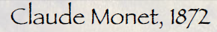  To know how to approach landscape painting, beginning with sky, background and ending with foreground and detail  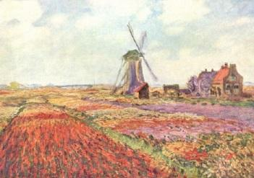  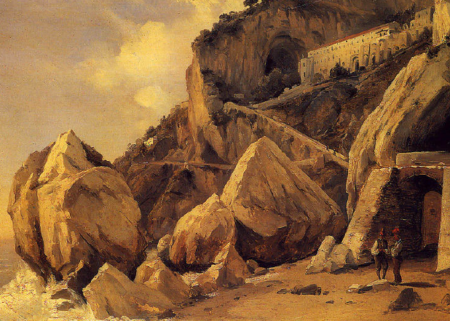 |  | To collect visual information to help develop ideas about the environment.  To understand that artists who have  portrayed the environment in a variety of ways.  Artists make parallel lines, to make it look as though the object is getting further  away.  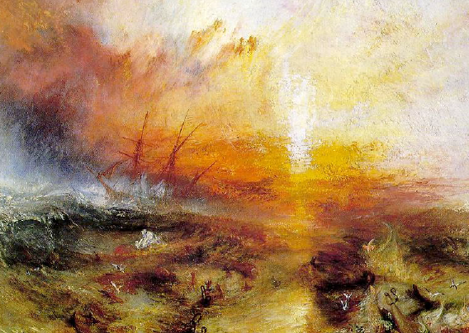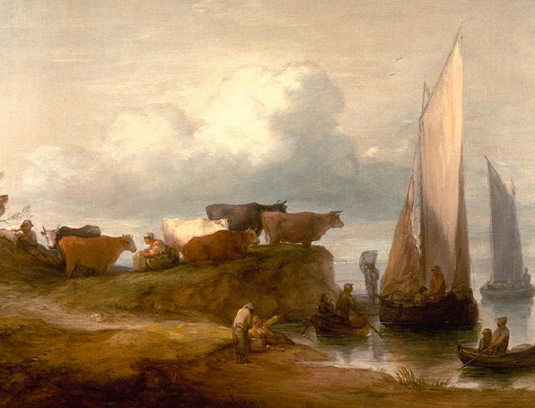  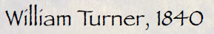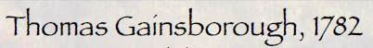
Viewfinder | A viewfinder is a simple square or rectangle cut out of card that you can look through
Perspective’ | refers to the way in which artists  manipulate a flat surface to bring the viewer into the space, so that it looks like you could walk into the painting.
watercolour | water based paint (part paint & part water)
tone | refers to the lightness and darkness of an object
shade | a mixture with black which increases darkness
dilute | to add water to paint in order to produce paler colours
The 5 elements of landscape painting |  |  | Key colours |  |  | Key skills
Colour: Colour is an important design consideration for landscape painting.  Line: Lines are related to the eye’s movement or flow. They can be created vertically, horizontally or curvilinear.  Form: Form is associated with three dimensional objects like trees and shrubs  Texture: Texture is a subtle but important element of landscape design.  Scale: Scale refers to the size of an object or objects in relation to the surroundings |  |  | 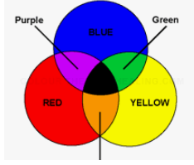  Primary colours : blue, yellow and red.  Three Secondary Colours: Orange, Green, Violet.  Six Tertiary Colours: Red-Orange, Yellow-Orange, Yellow-Green, Blue-Green, Blue-Violet, Red-Violet, which are formed by mixing a primary with a secondary. |  |  | 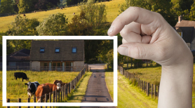  - to use a viewfinder to select interesting views or features.  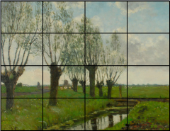  - to use a grid to proportion a landscape painting.  - To design and create a landscape and to evaluate own work and others

Expectations: Can children use a viewfinder to select interesting, views or features? Can children describe how artists use perspective painting?
Can children design and create a landscape using different colour schemes.

