Year 5 Spring 1 Frida Kahlo
Key Vocabulary |  |  | Key knowledge |  | Key concepts
Self portrait | a portrait that an artist produces of  themselves |  | Who is Frida Kahlo?  Frida Kahlo (6 July 1907 – 13 July 1954) was a Mexican painter. She was known for her surreal and very personal works. She was married to Diego Rivera, also a well-known painter.  When she was a child, Frida loved to draw. She preferred to spend hours on her own, being creative, rather than playing with her siblings.  She was training to become a doctor, but a tragic accident meant she was often in pain. She became an artist instead. You can often see signs of pain in her paintings. She often had to paint from her bed and had a special easel made.  She is famous for herself portraits. 55 of her 143 paintings were self-portraits, rich in symbolism.  Frida was very proud of her Mexican heritage and  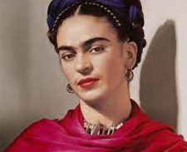  you can see lots of signs of Mexican culture in her  paintings. |  | - Learn about Frida Kahlo and study some of her paintings.  - Investigate how she uses colours in her art work to express emotions.  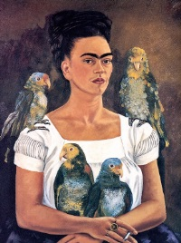  - To know how Kahlo would exaggerate some of her features in her paintings which became part of her identity and was widely recognised because of them.  - To understand what surrealism is in artwork  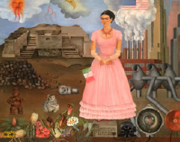
Realism | the quality or fact of representing a  person or thing in a way that is accurate and true to life.
Symbolism | an artistic and poetic movement or style using symbolic images and indirect  suggestion to express mystical  ideas, emotions, and states of mind
Surrealism | a 20th-century avant-garde movement in art and literature which sought to release the creative potential of the unconscious  mind, for example by the irrational  juxtaposition of images.
heritage | Features belonging to the culture of a  particular society, such as traditions,  languages, clothing, animals.
culture | The way of life, especially the general  customs and beliefs, of a particular  group of people at a particular time.
Mexico | Country in Central America next to USA
 |  |  | Key colours |  | Key skills
Frida Kahlo’s paintings  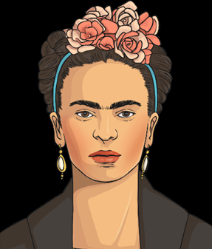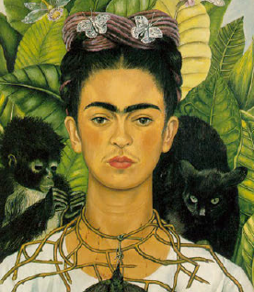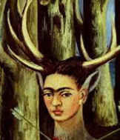 |  |  | vivid shades of red,  green,  yellow,  orange,  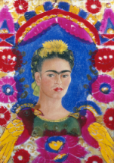  blue |  | 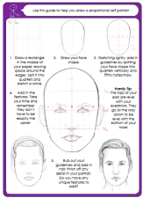  - To analyse some Frida Kahlo’s work.  - to sketch a self-portrait using proportions.  - ato apply aspects of surrealism to their artwork?

Expectations: Can children describe the differences between a portrait and a self-portrait? Can children describe the general proportions of a face?
Can children identify their own cultural background and use artwork to express this? Are children able to apply aspects of surrealism to their own artwork?

