Year 5 Chinese Art Autumn 1
Key Vocabulary |  |  | Key knowledge |  | Key concepts
dynasty | A line of rulers of a country from the same family. Parts of modern-day China were ruled by different dynasties for thousands of years. |  | What is Chinese Art?  - The earliest Chinese art is around the year 5000 B.C in the form of prehistoric clay pots.  - The dragon is an important symbol in Chinese culture.  - Chinese art is a very linear art form.  - The Four Gentlemen are four plants: bamboo, plum blossom, orchid and chrysanthemum.  - Chinese calligraphy is importance of brushstrokes |  | In this unit of work, the children will learn about traditional Chinese art and the art created during the Shang Dynasty civilisation. They will learn to analyse and evaluate their work as well as explore how the brushstrokes are used to create chine art work. They will use expressive brushstrokes to create a harmonious composition that reflected the energy of the scene they were painting.
Ming dynasty | Chinese dynasty from 1368-1644 C.E.
Porcelain | A white translucent ceramic.
Calligraphy | the writing of Chinese characters as  an art form.
Terracotta | a type of fired clay,
Brushstroke | a mark made by a paintbrush drawn across a surface.
Character | Chinese writing symbols
Where is China? |  |  | Key colours use in Chinese art? |  | Key skills
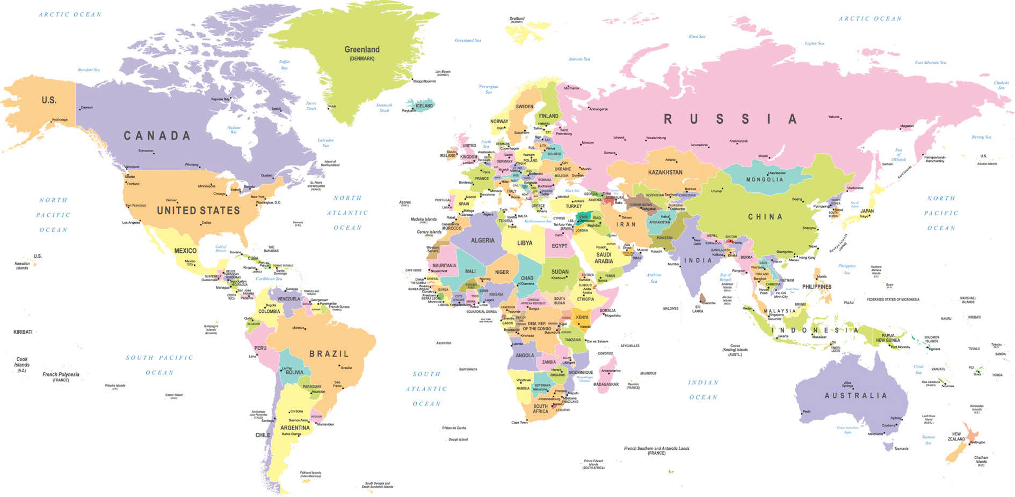  China is a large country in Asia. It has a long history  and a fascinating culture that dates back to prehistoric  times. China is the world’s most populous country with  around 1.4 billion people. |  |  | What colours have been used?  Primary colours  (white, yellow, red, blue, black  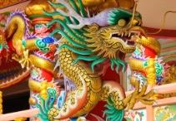 |  | - To use salt dough to make a Chinese dragon  - To use the brush strokes  - To find out about and replicate Chinese calligraphy  - To use clay to recreate a terracotta  - To know how to evaluate my own and others work.
Expectations

to paint one of the Four Gentlemen using the brushstrokes . To use salt dough to make a Chinese dragon, To use Chinese calligraphy to write some symbols. To use clay to recreate a terracotta, to use blue fine tip pens to decorate a vase in the style of Ming porcelain.

