Year 5 Spring Term 2023 Curriculum

We would firstly like to wish you all a Happy New Year; we hope you had a good Christmas break.

English
This spring term year 5 children will study the work of R.J Palacio- Wonder. It is about a boy who was born with a facial difference that has prevented him from going to a mainstream school. The work will help the children to explore many important issues such as family relationships, friendships and acceptance. Wonder will help the children to see the world from a different perspective. Studying the novel will help the children to consider the author’s use of language in presenting certain issues. They will learn to use evidence from the text to make inferences relating to the characters, and to write empathetically, exploring a range of thoughts and feelings. They will be using the book to support their writing across a range of genres such as instructions, description, narrative story forms and explanation texts. The children will develop their use of punctuation and complex sentences when writing independently. They will also use the story to develop their reading comprehension skills, responding to related questions in writing. Speaking and Listening opportunities will occur through class discussion about the text, hot seating activities and drama sessions.

The book is available online for the children to read and study the story:
https://st-marys-bognor.co.uk/wp-content/uploads/2020/05/Wonder-by-R.J.-Palacio.pdf
(For Parent reference only – PLEASE DO NOT READ AHEAD WITH YOUR CHILDREN AS LESSONS ARE PLANNED ON THIS TEXT).

Maths
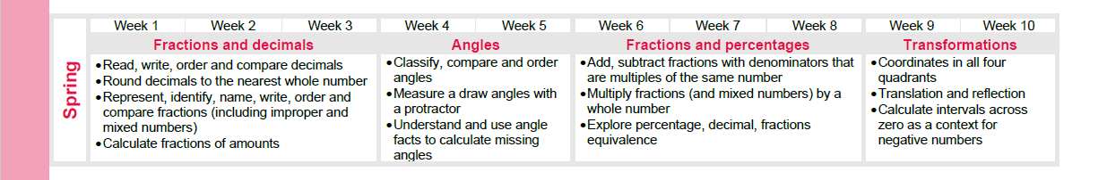
The Maths Mastery scheme is followed and this term the children will study a range of different concepts outlined below:
Spring 1
Fractions and decimals – Children will learn to understand and use numbers with up to 3 decimal places; read and write decimals as fractions; solve problems involving measure with all four operators.
Angles – Children will learn to estimate and compare acute, obtuse and reflex angles; draw given angles, measure in degrees; identify totals of angles at a point and on a straight line.
Spring 2
Fractions and percentages- Children will learn to understand percentages and convert to fractions/decimals; add/subtracts fractions with different denominators; multiply fractions by whole numbers; solve problems with all of the above.
Transformations- Children will learn to identify and describe translations and positions of shapes with appropriate language; deduce missing lengths and angles.

In history, we’ll be finding out about:
- The Vikings -Would the Vikings do anything for money?

In geography, we’ll be finding out about:
- Europe – A Study of the Alpine Region - Where should we go on holiday?

In art/DT, we’ll be looking at:
- Frida Kahlo -A famous artist. The children will explore how Kahlo drew on her cultural heritage for her artwork
- Making African musical instruments

In science, we’ll be looking at:
- Separating mixtures
- Types of change
In French, we'll be looking at:
- Habitats
- Goldilocks

In computing, we'll be exploring:
- Data Handling - Mars Rover
- Programming - Micro:bit
In music, we’ll be looking at:
- Make You Feel my Love
- The Fresh Prince of Bel Air
In RE, we’ll be exploring:
- Beliefs and moral values - Sikhism
- Easter (salvation) - Christianity

P.E Days:
Eagle: Wednesday (indoor)
Hawk: Thursday (indoor)
Osprey: Monday (indoor)
Please ensure your child brings their PE kits into school on their PE days. They will change at
the beginning of the lesson and back into school uniform at the end of the lesson.

Should you have any further questions please do not hesitate to contact us.
Thank you for your continued support.
Yours sincerely,

The Year 5 Team:

t.lilie@westbrookprimary.co.uk
Mr Lillie

a.mohammed@westbrookprimary.co.uk
Miss Mohammed

m.honeghan-bates@westbrookprimary.co.uk
Ms Honeghan-Bates

j.chohan@westbrookprimary.co.uk
Mrs Chohan

f.shaikh@westbrookprimary.co.uk
Mrs Shaikh

