Design an emoji competition
As part of Safer Internet Day (05.02.19) we want to encourage children to explore the positive power of image to create a better internet so we have asked them to design and make an emoji.

An emoji is a picture symbolising an emotion that is widely used online.
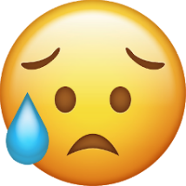

Be as creative as you can…
You could use Hama beads, Lego, colouring pens / pencils, paper mâche, play dough the possibilities are endless!
Bring your creation in to school on Monday 4th February.
There will be a prize awarded to each class for the best entry and these will be displayed in assembly.


