New Meal Ordering System
As we said in our last newsletter we are changing the way you can order your child’s school dinner.
From Friday 30th October 2020 you will be able to login to your child’s school gateway app and pre book dinners. When you book the meals you will need to pay for them straight away or the meal will not be confirmed, unless you are free school meals then your balance will show as £0.00
You will not be able to see your child’s current balance until you start using the app to make payments or order meals.
When you login to the school gateway you will need to click on the Lunch Money tab. 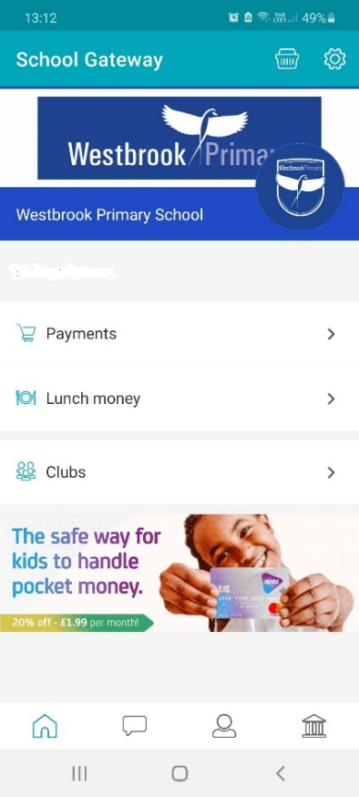
then click on Make/View Meal Bookings

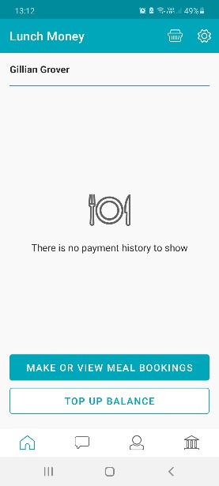
here you will be able to choose your child’s meal for the week and also top up the account if you need to.
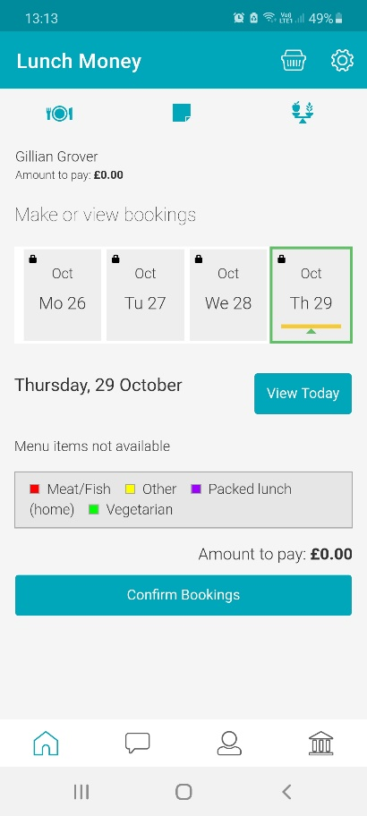

Scroll the date to the left till you can see the 2nd Novemeber and click this

You will then see the options for that day and you click the meal your child would like 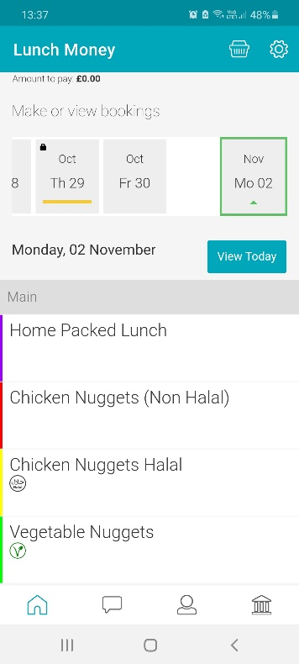

The Same rules apply as before that children need to stick to either packed lunch or a hot school meal for half a term they cannot change daily/weekly.

We suggest that you login every Sunday and book for the following week. If you should forget your child will be able to choose a meal in class in the morning but we would prefer this is done at home at the weekend. You can book more than one week at a time but you will have to pay for these at the time you order.
If your Child is entitled to Free School Meals or is in Reception, Year 1 or Year 2 you will still need to login and choose your child’s meal from home and you will not be charged.
If your child is off sick or is not attending for a day and you have booked a meal as long as you have informed the school office on the day by 10am you will not be charged for that day.
Ordering your child’s meal can easily be done on your smartphone/tablet by downloading the School gateway app. If you have not already done so then please use the relevant link below.
https://itunes.apple.com/ae/app/school-gateway/id596039615?mt=8

https://play.google.com/store/apps/details?id=com.schoolcomms.sga&hl=en
If you have any problems with the new app then please contact the office by phone or email and we will be happy to guide you through the process. office@westbrookprimary.co.uk

