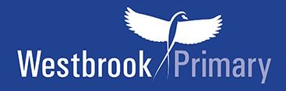
Year 5 recommended book list
Hounslow Library Service and another local primary school have put together a recommended book list which is pitched at Year 5 ability. We would like to share that list with you.

Your child can, of course, choose books to read which are easier or harder to read than the Year 5 recommended list. Why not see how many they can read from the list in a year?

Recommended optional study workbooks for Year 5
We are also selling Collins workbooks. These workbooks are optional and will help you support your child with reading, writing and Maths.

Year 5 novels
If your child can read these books below and talk about them, then they are able to read at the expected age level for Year 5.

Please note the books highlighted in yellow in the list below are good to start off with as they are slightly easier to read.
Year 5 - Novels |  | Price
***(Slightly easier read)***  The Highwayman by Alfred Noyes | 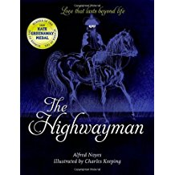 | £7.99
***(Slightly easier read)***  The Grunts in Trouble by Philip Ardagh | 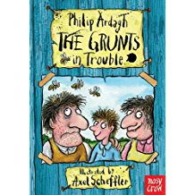 | £5.99
The story of Tracey Beaker by Jacqueline Wilson | 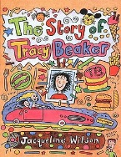 | £6.99
Dial a Ghost by Eva Ibbotson | 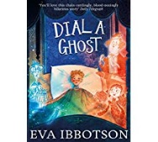 | £5.99
The Astounding Broccoli Boy by Frank Cottrell Boyce | 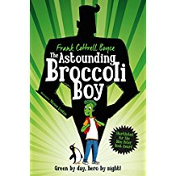 | £6.99
The Person Controller by David Baddiel | 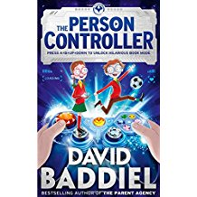 | £6.99
Matilda by Roald Dahl | 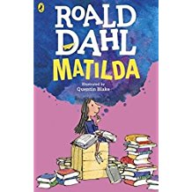 | £6.99
How to Update your Parents by Pete Johnson | 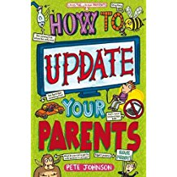 | £5.99

Year 5+ novels
If your child can read these books below and talk about them, then they are reading towards the Year 6 standard.

Recommended novels for Year 5+ |  | Price
Wolf Brother by Michelle Paver | 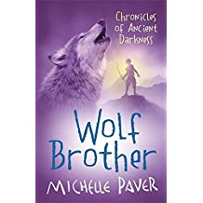 | £7.99
A Boy Called Hope by Lara Williamson | 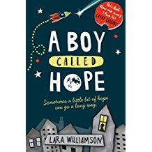 | £6.99
The London Eye Mystery by Siobhan Dowd | 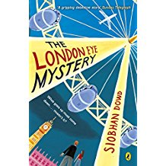 | £6.99
Harry Potter and the Philosophers stone by J.K. Rowling | 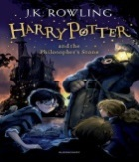 | £6.99
Hacker: Log in by Malorie Blackman | 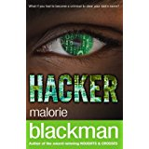 | £6.99
Truckers by Terry Pratchett | 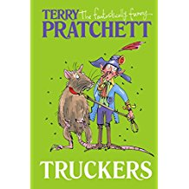 | £6.99
Beowulf by Michael Morpurgo | 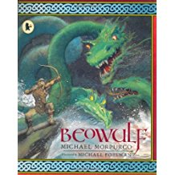 | £5.99

