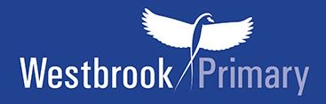

Year 3 Recommended book list
Hounslow Library Service and another local primary school have put together a recommended book list which is pitched at Year 3 ability. We would like to share that list with you.

Your child can, of course, choose books to read which are easier or harder to read than the Year 3 recommended list. Why not see how many they can read from the list in a year?

Year 3 novels
If your child can read these books below and talk about them, then they are able to read at the expected age level for Year 3.

Please note the books highlighted in yellow in the list below are good to start off with as they are slightly easier to read.
Recommended book list for Year 3 |  | Price
***(Slightly easier read)***  Daisy and the Trouble with Burglars by Kes Gray | 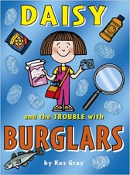 | £5.99
***(Slightly easier read)***  The Dragonsitter  by Josh Lacey | 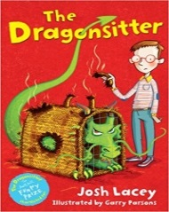 | £4.99
The Worst Witch by Jill Murphy | 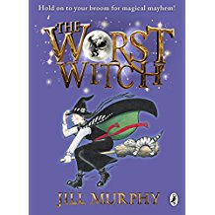 | £5.99
Oliver and the Seawigs by Philip Reeve | 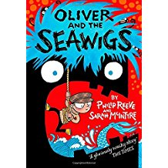 | £6.99
The No.1 Car Spotter and the Car Thieves by Atinuke | 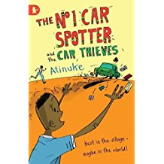 | £5.99
Flat Stanley by Jeff Brown | 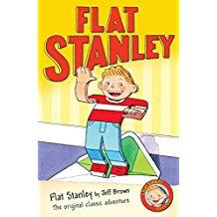 | £4.99
The Hundred-Mile-An-Hour Dog by Jeremy Strong | 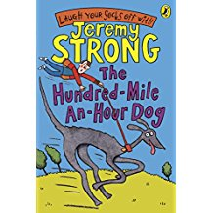 | £5.99
Clarice Bean, That’s me by Lauren Child | 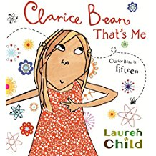 | £6.99
The Hodgeheg by Dick King-Smith | 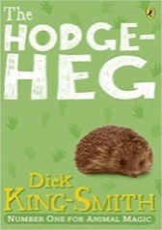 | £5.99

Year 3+ novels
If your child can read these books below and talk about them, then they are reading towards the Year 4 standard.

Please note the books highlighted in yellow in the list below are good to start off with as they are slightly easier to read.
Recommended novels for Year 3+ |  | Price
***(Slightly easier read)***  Timmy Failure: We Meet Again by Stephen Pastis | 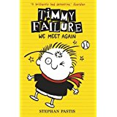 | £6.99
Fortunately the Milk by Neil Gaiman | 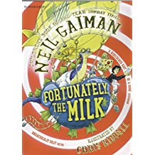 | £6.99
The Invincible Tony Spears by Neal Layton | 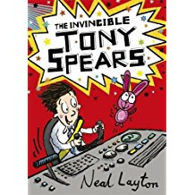 | £7.99
A Tiger Tale by Holly Webb | 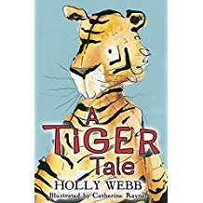 | £5.99
Surprises According to Humphrey by Betty G. Birney | 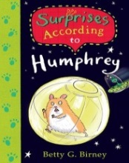 | £5.99
Buckle and Squash and the Land of the Giants by Sarah Courtauld | 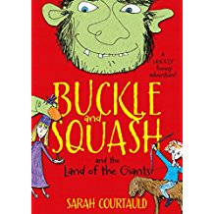 | £5.99

