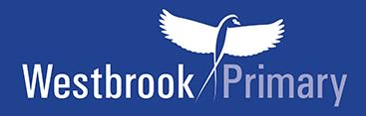
Year 6 recommended book list
Working with Hounslow Library Service we have put together a recommended book list which is pitched at Year 6 ability.

Your child can, of course, choose books to read which are easier or harder to read than the Year 6 recommended list. Why not see how many they can read from the list in a year?

Year 6 novels
If your child can read these books below and talk about them, then they are able to read at the expected age level for Year 6.

Please note the books highlighted in yellow in the list below are good to start off with as they are slightly easier to read.
Year 6 - Novels |  | Price
***(Slightly easier read)***  Black powder by Ally Sherrick | 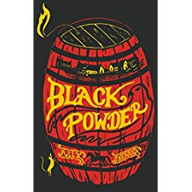 | £6.99
***(Slightly easier read)***  Once by Morris Gleitzman | 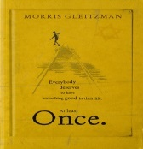 | £6.99
Butterfly Summer by Anne-Marie Conway | 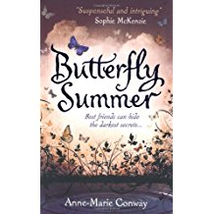 | £6.99
The Witches by Roald Dahl | 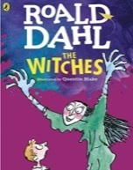 | £6.99
The Bubble Boy by Stewart Foster | 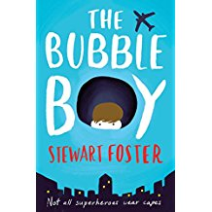 | £6.99
Artemis Fowl by Eoin Colfer | 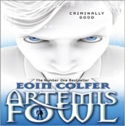 | £6.99
Knightley and Son by Rohan Gavin | 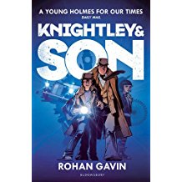 | £6.99
In Darkling Wood by Emma Carroll | 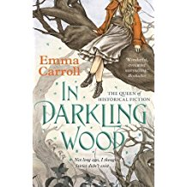 | £6.99
A Pocket Full of Murder by A.J. Anderson | 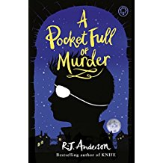 | £6.99

Year 6+ novels
If your child can read these books below and talk about them, then they are reading towards the higher Year 6 standard.

Recommended novels for Year 6+ |  | Price
Journey to the River Sea by Eva Ibbotson | 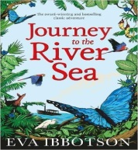 | £6.99
Murder Most Unladylike by Robin Stevens | 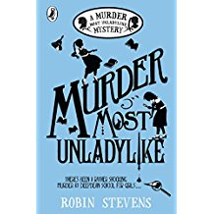 | £6.99
The Ghosts of Shanghai by Julian Sedgwick | 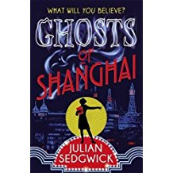 | £6.99
Holes by Louis Sachar | 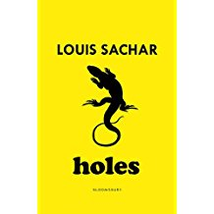 | £6.99
Cogheart by Peter Bunzl | 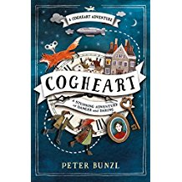 | £6.99
I, Coriander by Sally Gardner | 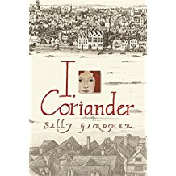 | £7.99
Swallows and Amazons by Arthur Ransome | 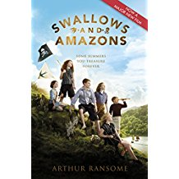 | £7.99

