Why should people fight? 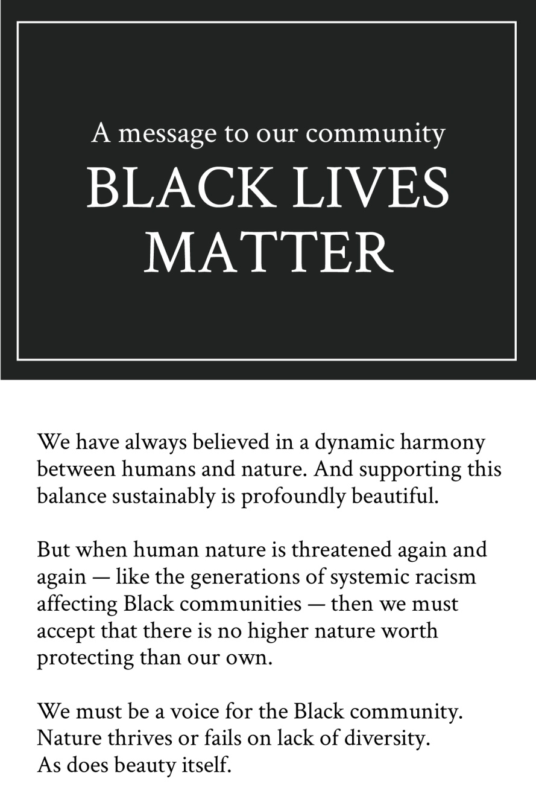
Why should people treat other people unfairly just because they do not like the colour of someone else’s skin?
BLM. Why should Black lives not matter? All lives matter and everyone should have an equal life regardless of the race or religion.
People do not fight because they have lost something, they fight because they care about something so that’s why people protest because they care about black lives and about their future.

