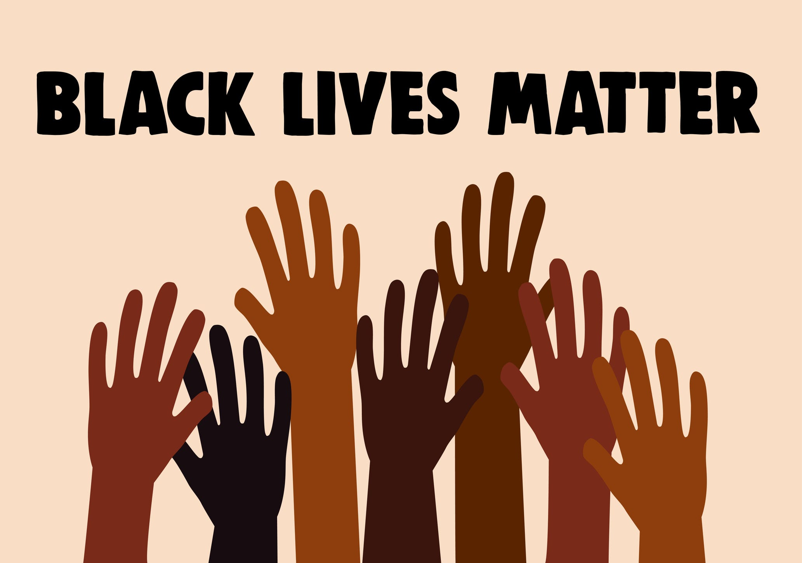
White feelings should never be held in higher regard than black lives, while in a racist society, it’s not enough to be non-racist, we must be anti-racist.

