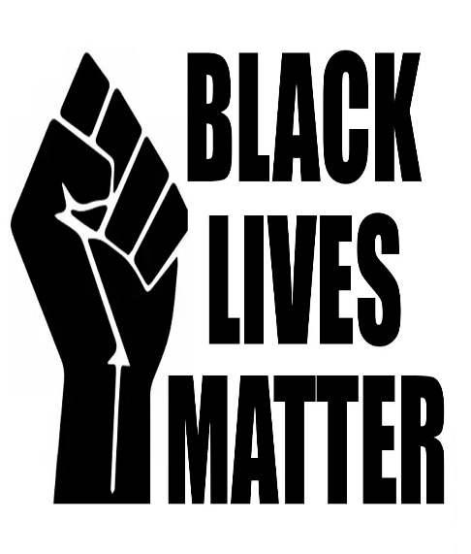
Racism is disgusting, we are all the same and just because they have different skin colour doesn’t mean they get treated differently. They are human, we are human and we are all the same. We should get treated equally. How would you feel if that happened to you?
The incident about George Floyd an African American man who died in Minneapolis at 25th of May 2020.He was handcuffed by police and laid on the floor while a white policeman called Derek Chauvin placed his knee on his neck for eight whole minutes straight. Later Floyd yelled “help I can’t breathe! “After a while he was rushed to hospital and unfortunately passed away.
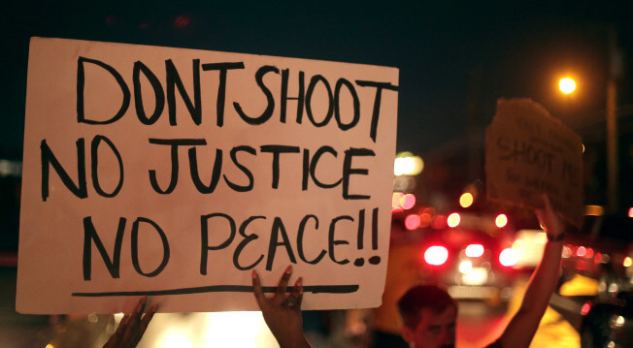

Not just black lives matter but all lives matter. When there is no justice then there is no peace. The unfortunate death of George Floyd has made everybody around the world freak out about George Floyd.

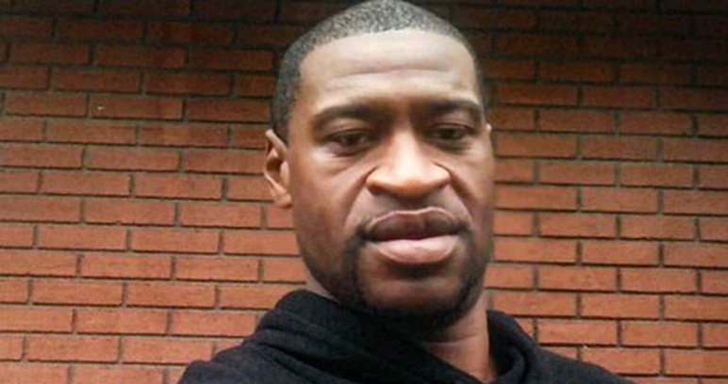
Rest in peace George Floyd.

