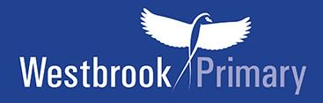

Year 4 recommended book list
Hounslow Library Service and another local primary school have put together a recommended book list which is pitched at Year 4 ability. We would like to share that list with you.

Your child can, of course, choose books to read which are easier or harder to read than the Year 4 recommended list. Why not see how many they can read from the list in a year?

Year 4 novels
If your child can read these books below and talk about them, then they are able to read at the expected age level for Year 4.

Please note the books highlighted in yellow in the list below are good to start off with as they are slightly easier to read.
Recommended book list for Year 4 |  | Price
***(Slightly easier read)***  You’re a Bad Man Mr Gum by Andy Stanton | 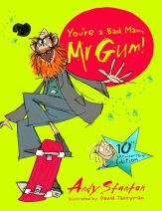 | £6.99
***(Slightly easier read)***  Bob’s Film Fiasco by Simon Bartram | 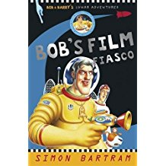 | £4.99
You’re Amazing Anna Hibiscus by Atinuke | 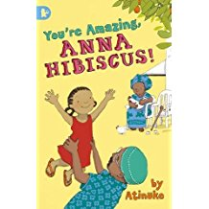 | £5.99
I was a Rat by Philip Pullman | 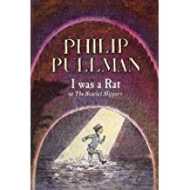 | £6.99
Bill’s New Frock by Anne Fine | 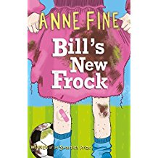 | £5.99
The Adventures of Alfie Onion by Vivian French | 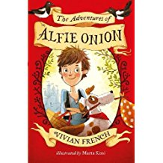 | £5.99
Wayside School gets a Little Stranger by Louis Sachar | 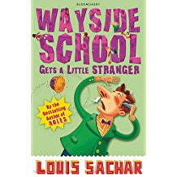 | £4.99
Dragons at Crumbling Castle by Terry Pratchett | 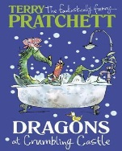 | £6.99
The Killer Underpants by Michael Lawrence | 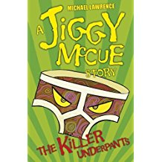 | £5.99

Year 4+ novels
If your child can read these books below and talk about them, then they are reading towards the Year 5 standard.

Please note the books highlighted in yellow in the list below are good to start off with as they are slightly easier to read.
RRecommended novels for Year 4+ |  | Price
***(Slightly easier read)***  The Accidental Prime Minister by Tom Mclaughlin | 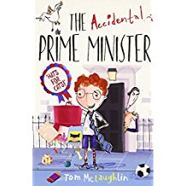 | £6.99
***(Slightly easier read)***  Diary of a Wimpy Kid by Jeff Kinney | 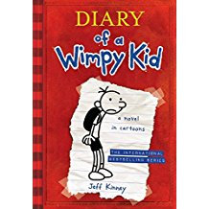 | £6.99
Three Pickled Herrings: the Second Case by Sally Gardner | 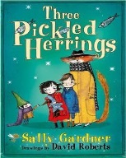 | £5.99
Charlotte’s Web by E.B. White | 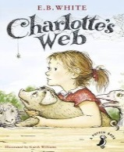 | £6.99
The Boy who Swam with Piranhas by David Almond | 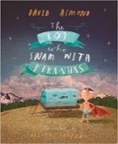 | £6.99
Street Child  by Berlie Doherty | 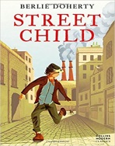 | £6.99

